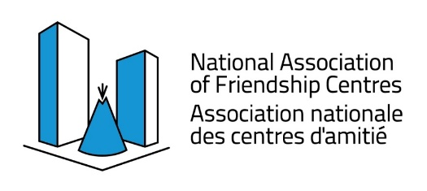

Urban Programming for Indigenous Peoples
FINAL REPORT
Organizational Capacity Funding Stream

BC Association of Aboriginal Friendship Centres
551 Chatham Street, Victoria, BC V8T 1E1
Phone: 250-388-5522 Toll Free 1-800-992-2432
Email: reporting@bcaafc.com

Fiscal Year | 2022/2023
Friendship Centre | choose friendship centre
Organizational Capacity Program Questions
How did this funding support/improve/increase existing programs and services?
Did your centre experience any funding shortfalls and if yes, describe how these shortfalls impact your centre
Organizational Capacity Success Stories
Strategically, what was the biggest success for your centre this year?
For the positions funded or partially funded by OC, what was their biggest success this year?
(Optional) Any general OC story you would like to share.

NOTE – Any submitted pictures must:
- Pertain to success story activities described in this report.
- Be submitted as .jpg or .png files only.
- Be named appropriately with brief description as part of the file name ex: BCAAFC_EldersLunch_OC2023.png
Final Reporting Due: April 20, 2023
Phone: 250-388-5522 Toll Free 1-800-992-2432
Email: reporting@bcaafc.com

