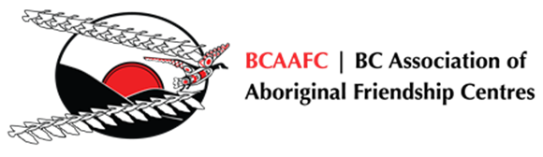

Employment,
Life Skills & Training

Interim Narrative Report

BC Association of Aboriginal Friendship Centres
551 Chatham Street, Victoria, BC V8T 1E1
Phone: 250-388-5522 Toll Free 1-800-992-2432
Fax: 250-388-5502 Email: reporting@bcaafc.com
Name of Friendship Centre:
Report period – 2nd Quarter | July 15, 2023 to November 30, 2023
Report period – 3rd Quarter | December 1, 2023 to February 28, 2024.

Please complete the following sections. Expand the sections as needed.
Identify any group training that was offered in the report period (see dates above). Include:
- How many participants were served in each group?
- How many participants completed the training?
- What was the duration of the training (days/weeks)?
- Was there a certificate given upon completion (first aid, WHMIS, etc)?

ANSWER:
[answer here]

Identify any cultural components or supports offered. This could include services provided by an Elder.

ANSWER:
[answer here]

Please provide any additional comments related to your experience in delivering the project.

ANSWER:
[answer here]

SUCCESS STORIES AND PICTURES
Please send at least one success story and picture you want to share with Testimonial Consent and Release Form(s) with this report. If you need a copy of these forms please contact Yvonne at ytrott@bcaafc.com.

Success looks different to everyone, maybe it is the first time someone has accessed funding, or taken part in a skills training course etc. This feedback informs future decisions if our programs gets further funding.

Submitted by: Name | Title

