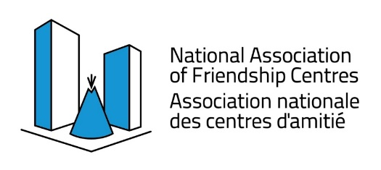

Urban Programming for Indigenous Peoples
FINAL REPORT
Programs & Services Project Funding Stream

BC Association of Aboriginal Friendship Centres
551 Chatham Street, Victoria, BC V8T 1E1
Phone: 250-388-5522
Email: reporting@bcaafc.com

Fiscal | 2023/2024
Choose Friendship Centre | choose friendship centre
Key Project Area: | choose key project area
Project Title:
# of Participants:
# of Satisfied Participants
# of Women:
# of Youth:
# of Vulnerable Persons:
# of Program Activities:
Programs and Services Narratives
Success story demonstrating client satisfaction
Success Story demonstrating positive impacts of project more broadly
Programs Delivery Feedback - Program Management Perspective
What was the most successful part of your program roll-out?
What was the least successful part of your program roll-out?
How did your project meet the objective or priority areas of the funding?

NOTE – Any submitted pictures must:
- Pertain to success story activities described in this report.
- Be submitted as .jpg or .png files only.
- Be named appropriately with brief description as part of the file name ex: BCAAFC_EldersLunch_PS2024.png
Final Reporting Due: April 18, 2024

The activities and outputs of the Programs and Services funding stream are to support investments in projects which support transitions to cities from reserves and northern and remote communities, and which attract additional investments to increase participation in the economy. Programs and Services initiatives and projects eligible for funding support are:
- Projects that support new and existing general programs and services that serve urban Indigenous peoples that address locally-identified issues, provided that they are not already
- funded or eligible to be funded by other departments or governments.
- Funding will be eligible in six key areas including:
- women (such as projects to help women transition out of shelters)
- vulnerable populations (such as projects for persons with addictions, disabilities, seniors)
- youth (such as projects that provide land-based activities, mentoring)
- transition services (such as navigator services)
- outreach programs (such as cultural awareness training for non-Indigenous organizations)
- community wellness (such as housing plans or studies, anti-racism, pre-employment supports)
The Programs and Services provides funding support for projects. Funding provided to projects must be for specific activities and is not to be used to support an organization's ongoing operations, is not intended to supplement a shortage of funding under another program or initiative of any order of government, or support an already successful program or initiative, especially as a repetitive delivery offering.
Investments made through the Programs and Services funding stream will reduce barriers, whether real or perceived, to urban Indigenous peoples’ participation in the society by achieving one or more of the following expected results:
- Urban Indigenous community groups and organizations have enhanced capacity to be self-reliant in seeking meaningful partnerships with traditional and non-traditional partners;
- Partners collaborate on policy, program, planning and projects towards improving socio-economic conditions for urban Indigenous peoples, with a focus on Indigenous youth;
- Projects enable and empower urban Indigenous peoples to access available culturally appropriate programs and services;
- Projects ease Indigenous peoples’ transitions to urban centres from reserves and northern and more remote communities;
- Projects attract additional investments and leverage resources, infrastructure and supports available to urban Indigenous peoples.

For additional information on the UPIP or for assistance in filling in the report, please contact:

By email: reporting@bcaafc.com
By phone: 250 388 5522

Final Reporting Due: April 18th, 2024

